

**Computer Science Final-Year Project**

**Ethics Application Form 2019-20**

**Applicant details**

|  |  |
| --- | --- |
| **Project title** | **Detecting Political Bias in Text** |
| **Name of final-year project student** | **Richard Jones** |
| **Keele e-mail address of student** | **w8a76@students.keele.ac.uk** |
| **Name of project supervisor** | **Dr. Charles Day** |

**Project Summary**

|  |
| --- |
| This project focuses around the design and development of a system that takes a variable length set of text (such as a paragraph) as an input and (using machine learning techniques) detects any political bias the text may hold.  The system has been developed around a Long-Short Term Memory Neural Network (LSTM) which has been trained on publicly available data from Parliamentary debates.  The output of the system will be recorded in a database for later querying, and an interface will be constructed around the system for a user to interact with the Neural Network. |

|  |
| --- |
| **In simple terms, provide a *short* description of your planned experimental method that involves participants (e.g., focus groups, questionnaires, interviews, experimental observations).**   * A User-Testing session will be carried out for each participant, where each user will be asked to carry out specific tasks on the developed software. * After the user has completed all of the tasks, they will be given a short survey enquiring about their thoughts and feelings about the effectiveness, performance and usability of the design. |

|  |
| --- |
| **Describe the characteristics of your participants, and any inclusion or exclusion criteria. Estimate the approximate number of participants.**  Participants will include students from the Keele University Computing and Maths Department, as well as registered participants collated by the BCS.  Approximately 15-20 participants will be recruited for the User-Testing and Questionnaire sessions |

**Recruitment and Consent**

|  |
| --- |
| **Indicate how potential participants will be identified, approached and recruited and outline any relationship between the researcher and potential participants.**  Student participants will be chosen from all levels of the University undergraduate program and any researchers chosen by the school from the BCS.  Potential participants will be approached through an email stating briefly the aims of the project and what will be required of them during the research session. For added measure, a copy of the Research Participant Sheet and consent form will be attached to every email. |

|  |
| --- |
| **Describe the process that will be used to seek and obtain informed consent.**  If potential participants are interested in working on the project, a Consent Form will be provided in each of the recruitment emails, for the user to sign and return to myself. No participant will be allowed to continue the research until this consent form is signed. |

|  |
| --- |
| **Will consent be sought to use the data for other research**? Yes  No  **Will consent be sought to contact the individual to participate in future research?** Yes  No |

|  |
| --- |
| **Can participants withdraw from the research?** Yes  No  **If yes, state up to what point participants are able to withdraw from the research**  Participants will be able to withdraw from the research up to 7 days after the research session.  **If yes, outline how participants will be informed of their right to withdraw, how they can do this and what will happen to their data if they withdraw**  Withdrawal information will be provided on the Participant Information Sheet. |

**Confidentiality and anonymity**

|  |
| --- |
| **Outline the procedures that will be used to protect, as far as possible, the anonymity of participants and/or confidentiality of data during the conduct of the research and in the release of its findings.**  Any participant data that could lead to identification of the participant, will be anonymised (e.g. names and contact details will be replaced with unique identifiers) on all material relating to the surveys. |

**Storage, access to, management of, and disposal of data**

|  |
| --- |
| **Describe how participant data will be stored; where it will be stored and for how long; and how/when it will be disposed of.**  All electronic records of the research will be stored securely on the university profile drives, any obsolete paper data (such as consent forms and questionnaires that have been scanned into the school computers) will be shredded to avoid personal data being leaked to the public. At all points, only the participant, supervisor and researcher will be able or permitted to access this data. After the project has been completed, all participant data will be deleted). |

**Other ethical issues raised by the research**

|  |
| --- |
| **Are there any other ethical issues that may be raised by the research?** Yes  No |

**Declarations**

|  |
| --- |
| **Declaration by student**  I confirm that:   * The form is accurate to the best of my knowledge. * I will inform my supervisor and resubmit an ethical application if there are any changes to the project. * I am aware of my responsibility to comply with the requirements of the law and any relevant professional guidelines. |
| Student name Richard Jones |
| Student signature |
| Date 19/12/19 |

|  |
| --- |
| **Declaration by supervisor**  I confirm that:   * I have read the application and am happy for it to proceed for ethical review. * The application is accurate to the best of my knowledge. * I am aware of my responsibility to ensure that the applicant is familiar with and complies with the requirements of the law and any relevant professional guidelines. |
| Supervisor name |
| Supervisor signature |
| Date |



**Participant Information Sheet**

**Study Title**:

Detecting Political Bias in Text

**Aims of the Study**

This study aims to use Machine Learning techniques (such as Neural Networks) to detect political bias in text.

**Invitation**

This information sheet is an official invitation to take part in **Detecting Political Bias in Text**, a study undertaken by **Richard Jones**.

Please read through this information sheet carefully to ensure that it is something that you would feel comfortable and interested in doing. Please contact me using the details at the end of this sheet if you have any questions regarding the project.

**Why have I been invited?**

You have been selected as you are either a student of the Keele School of Computing and Mathematics, or a Research Participant collated by the BCS.

**Do I have to take part?**

You are not, under any circumstances, required to take part in this research. If you change your mind at all during the research session or up to a week after, steps will be taken to remove all of your personal data relating to the project. You will not need to provide reasons for your withdrawal.

**What will happen if I take part?**

You will be invited to a 30 to 45 minute session where you will be given a program to interact with and use. During this time, you will be given several tasks to undertake on the program as well as a brief description of what the program is aiming to do.

After this session, you will be provided with a short questionnaire that will measure your experience of the software through many categories. After filling in the questionnaire, you will be given an amount of time to ask any questions relating to the program and then will be free to go

**What are the benefits (if any) of taking part?**

Participating in this project research will give you the opportunity to evaluate and contribute to the design, usability and performance of this project. Furthermore, recruited candidates will also be given experience in user testing evaluation.

**What are the risks (if any) of taking part?**

No risks have been identified for this research participation.

**How will information about me be used?**

The questionnaire answers produced from every session will be compiled and analysed and stored securely on the university drives. Participant consent forms will also be scanned and securely stored on the University file-system. All physical copies of this data will be stored securely until the project has finished. Any withdrawal from the research participation will mean these forms are destroyed immediately in all forms.

This information will be collated, reported and evaluated in the dissertation, to provide a more insightful evaluation of the software developed in this project. The project will anonymise data (e.g. personal information replaced with codenames) when the data is reported on in the dissertation.

**Who will have access to information about me?**

As the data will be stored securely, until the end of the project where it is deleted, only the Research Student and Supervisor will have access to your information

**What if there is a problem?**

If you have any questions or concerns regarding this Project Research, please contact either the Research Student or Supervisor using these methods below.

**Research Student:** Richard Jones - w8a76@keele.ac.uk

**Supervisor:** Dr. Charles Day - c.r.day@keele.ac.uk



**CONSENT FORM**

**Title of Project:** Detecting Political Bias in Text

**Name and contact details of student investigator and supervisor:**

**Research Student:** Richard Jones - w8a76@keele.ac.uk

**Supervisor:** Dr. Charles Day - c.r.day@keele.ac.uk

## Please tick box if you agree with the statement

1. I confirm that I have read and understood the Participant Information Sheet and have had the opportunity to ask questions.
2. I understand that my participation is voluntary and that I can stop participating at any time and can withdraw my data up to **one week** after participation without giving a reason.
3. I agree to take part in this study.
4. I understand that data collected about me during this study will be anonymised before it is reported in any reported results.
5. I agree for my answers to all completed questionnaires to be used.

|  |  |  |
| --- | --- | --- |
| _______________________ Name of participant | __________________ Date | ____________________ Signature |
| _______________________  Student investigator | __________________ Date | ___________________ Signature |

**SYSTEM USABILITY SCALE QUESTIONNAIRE**

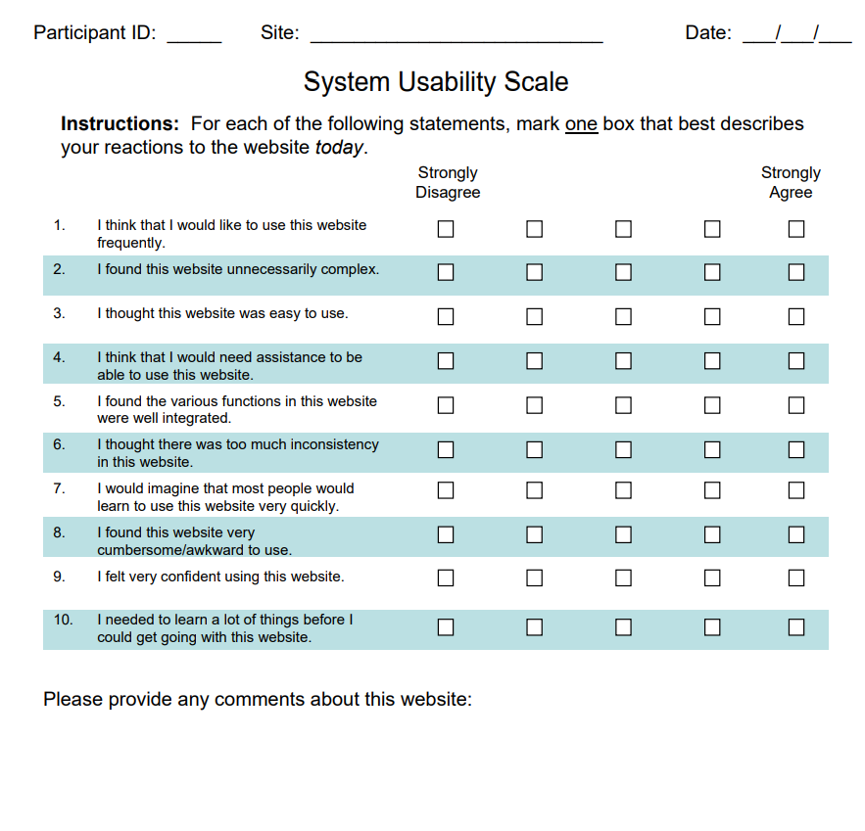

<https://www.measuringux.com/SUS.pdf>